Web Programming
Student’s Name: | Frem Fredric Baring Patalinghug
Id. No: | 04-24-184
Date  of Submission | May 15, 2025
GitHub Repository Name: | Eldeston/eldeston.github.io
GitHub Repository Link: | https://github.com/Eldeston/eldeston.github.io
Website Link | https://eldeston.github.io/
Theme (Topic) | Web Portfolio

Repository Screenshot
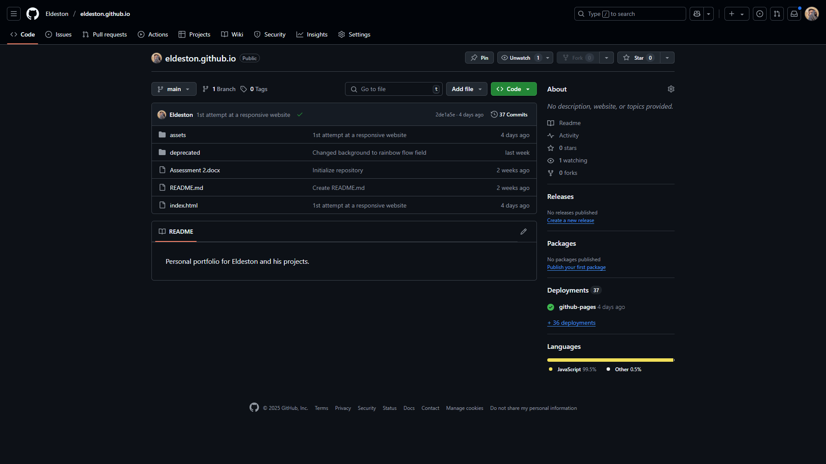
Brief
We are tasked to make a website of a theme among the 5 of our choosing using our knowledge in HTML, CSS, and JavaSript that we have learned throughout the semester.

For my theme I chose a personal website portfolio. The portfolio’s purpose is to showcase all of my skills and projects with design in mind.

Design Direction
I chose a web portfolio theme as it is the most practical one and most needed at the time. This is to also showcase all my personal projects and my skills in HTML and JavaScript by making a personal web portfolio.

The website is inspired by a long time online colleague, whose name is DrDesten, when I started learning about programming by making shaders for Minecraft.

With my colleague’s website as my inspiration, I decided to design my website with a modern programmer oriented theme. The following are the designs I incorporated into the website:

JetBrains Mono — A popular font for programmers for its design and readability.

Blinking Cursors — Animated through CSS to imitate a terminal line commonly used by programmers.

Typing Animation — Animated through JavaScript and only animates when the text element is in view.

Glass Effect — Used in the navigation bar, content windows, and footer for a modernized look.

Sheilds.io Badges — Commonly used in Github portfolios in README.md files to showcase achievements.

The animated background is an iframe element used to feature my skills in creative coding which is enhanced throughout the semester. The animated background is powered by p5.js, a graphics library for JavaScript useful for expressing creativity through code.

Interaction Overview
The website features a navigation bar and a footer and 7 navigational links to various parts of the page: About Me, Projects, Professions, FlameRender Studios (the clickable logo), Community, Software, and Subscribe.

Navigation Bar — Features the 7 navigational links including the clickable website logo. It also features button animation hovers.

About Me — Features a short biography about me and my personal background.

Projects — Features all of my best projects and milestones throughout my journey in programming.

Professions — Features a short description of my skill set and educational background.

FlameRender Studios — Features my 7 year old studio community where I showcase and develop my projects.

Community — Features my Discord server where FlameRender Studios resides.

Software — Features all of the professional tools I used to develop my projects.

Subscribe — Features all the my socials the user can follow or subscribe to be informed of my works.

Footer — Features all the clickable links, my email, and website and copyright info.

Technical Description
The website uses plenty of JavaScript and has a heavy emphasis on optimization to showcase my skill to optimize code. This is to also keep devices with weaker specifications running the website in mind in the making of this website.

The background of the website uses a fixed element that features p5.js powered graphics using JavaScript to showcase my mastery in JavaScript and creative coding skills. The background features a 4096 particle simulation prismatic flow field that is heavily optimized and tested to run on weaker devices.

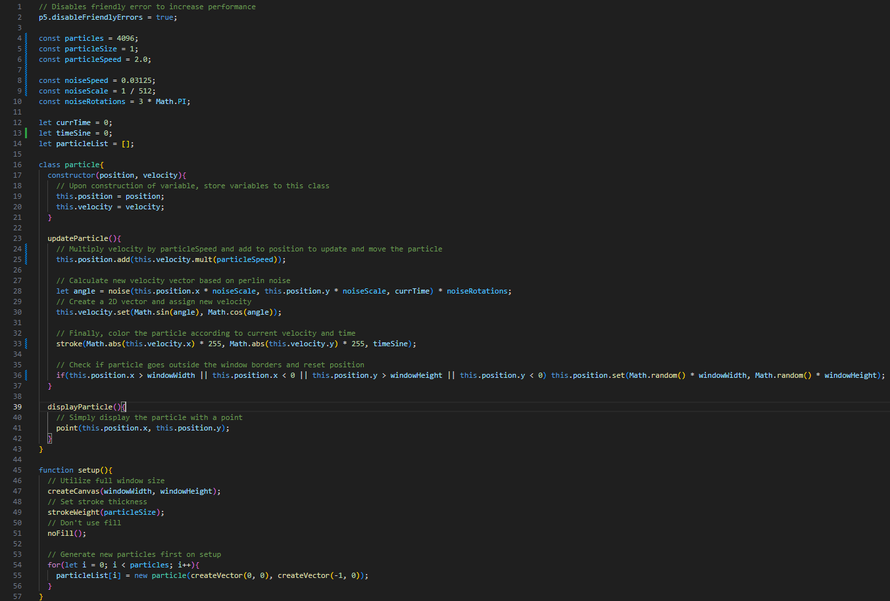
The flow field uses vectors to point the direction of the velocity of each particle. It accomplishes this by using perlin noise as a directional angle to change the direction of the vector. This new vector will then be used for changing the particle velocity’s direction. Finally, it adds the velocity per frame to move the particles according to the direction of the flow field. Additionally, the flow field changes its overall direction by time in seconds, and the particles change color according to the direction of the particle and the sine wave of time in seconds.

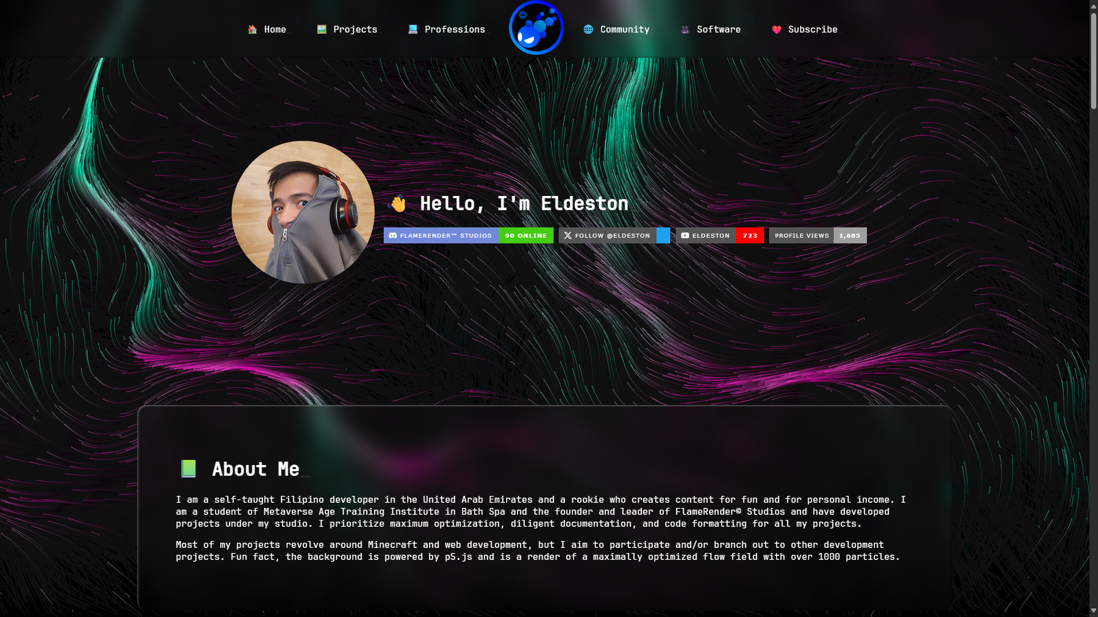
The headers used in this website also uses JavaScript to animate the typing animations. I chose to use JavaScript for the typing animations because it is more flexible and reusable compared to implementing the typing effect in CSS where it depended on the manual input of the length of the text. The code uses an observer class to check if the element is in view by checking for intersections instead of using .onScroll as it fires the script continuously while using an observer fires the script only once.

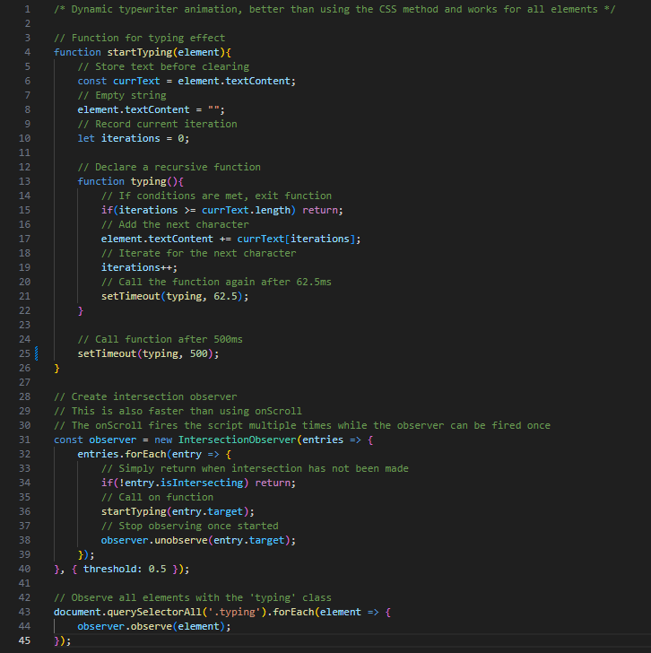
For CSS, the navigational bar features a hover animation for the button links that increases in margin and shifts the background. The logo in the navigational bar becomes bigger when hovered. The blinking cursor uses a simple looping animation of its opacity.
Critical Reflection
This website is one of my most proudest work for this semester combining my skills from previous subjects in Digital Visual Design, Creative Coding, and Web Programming into a single portfolio. I showed my mastery in programming while keeping design and function in mind.

While I exercise great flexibility with designing websites with Figma, I realized that it is extremely different on the developer side. For the developer, they face more challenges while also gaining more flexibility and options compared to designing a website in Figma where it is mostly static.

I learned that a good website is not complete without a back end. I faced the challenges of making a responsive website, browser compatibility, learned essential optimization skills for JavaScript and p5.js, and discovered how to use the debugging tools of my browser which helped dissect parts of my website.

I intend to continue updating this website to show more of my skills and showcase more of my works as I grow as a shader developer, web developer, and creative coder.

References
Desten, D. (2021). DrDesten - Home. [online] github.io. Available at: https://drdesten.github.io/web/ [Accessed 14 May 2025].
Lis, C. (2021). The Beauty of Code: Flow Fields. [online] youtu.be. Available at: https://youtu.be/na7LuZsW2UM?si=fcn7ihDuYiQt2zm5 [Accessed 14 May 2025].
p5.js (2019). p5.js | Home. [online] p5js.org. Available at: https://p5js.org/ [Accessed 14 May 2025].
W3 Schools (n.d.). How to Create a Typing Effect. [online] www.w3schools.com. Available at: https://www.w3schools.com/howto/howto_js_typewriter.asp [Accessed 14 May 2025].

